**ENTIRE MYSQL FILE**

**CREATE TABLE `commissioner` (**

**`salary` varchar(100) not null,**

**`name` varchar(100) not null,**

**`commissionerID` int not null PRIMARY KEY**

**);**

**CREATE TABLE `coach` (**

**`coachID` int not null PRIMARY KEY,**

**`name` varchar(100) not null,**

**`experience (years with current team)` int not null**

**);**

**CREATE TABLE `owner` (**

**`ownerID` int not null PRIMARY KEY,**

**`name` varchar(100) not null,**

**`Net Worth $` varchar(100) not null**

**);**

**CREATE TABLE `team` (**

**`teamID` int not null PRIMARY KEY,**

**`coachID` int not null,**

**`ownerID` int not null,**

**`name` varchar(100) not null,**

**FOREIGN KEY (`coachID`)**

**REFERENCES `coach` (`coachID`)**

**ON DELETE CASCADE**

**ON UPDATE CASCADE,**

**FOREIGN KEY (`ownerID`)**

**REFERENCES `owner` (`ownerID`)**

**ON DELETE CASCADE**

**ON UPDATE CASCADE**

**);**

**CREATE TABLE `player` (**

**`name` varchar(100) not null,**

**`position` varchar(100) not null,**

**`career average: points` double not null,**

**`salary` varchar(100) not null,**

**`teamID` int not null,**

**`team name` varchar(100) not null,**

**`playerID` int not null PRIMARY key,**

**FOREIGN KEY (`teamID`)**

**REFERENCES `team`(`teamID`)**

**ON DELETE CASCADE**

**ON UPDATE CASCADE**

**);**

**CREATE TABLE `game` (**

**`gameID`int not null PRIMARY KEY,**

**`team 1 ID` int not null,**

**`team 1 name` varchar(100) not null,**

**`team 1 score` int not null,**

**`team 2 ID` int not null,**

**`team 2 name` varchar(100) not null,**

**`team 2 score` int not null,**

**`date` varchar(100) not null,**

**`location` varchar(100) not null**

**);**

**CREATE TABLE `player_game_stats` (**

**`gameID` int not null,**

**`teamID` int not null,**

**`team name` varchar(100) not null,**

**`playerID` int not null,**

**`points` int not null,**

**`rebounds` int not null,**

**`assists` int not null,**

**`date` varchar(100) not null,**

**PRIMARY KEY(`gameID`, `playerID`),**

**FOREIGN KEY(`gameID`)**

**REFERENCES `game`(`gameID`)**

**ON DELETE CASCADE**

**ON UPDATE CASCADE,**

**FOREIGN KEY(`playerID`)**

**REFERENCES `player`(`playerID`)**

**ON DELETE CASCADE**

**ON UPDATE CASCADE**

**);**

**insert into commissioner values('$10,000,000', 'Adam Silver', 001);**

**insert into owner values (1, 'Peter Holt - San Antonio Spurs', '$200 Million ');**

**insert into owner values(2, 'Micky Arison - Miami Heat', '$9.6 Billion');**

**insert into owner values(3, 'Mark Cuban - Dallas Mavericks', '$3.4 Billion');**

**insert into owner values(4, 'Leslie Alexander - Houston Rockets', '$1.9 Billion');**

**insert into owner values (5, 'Glen Taylor - Minnesota Timberwolves', '$1.84 Billion');**

**insert into owner values (6, 'Robert J. Para - Memphis Grizzlies', '$3.3 Billion');**

**insert into coach values (1, 'Gregg Popovich', 21);**

**insert into coach values (2, 'Erik Spoelstra', 9);**

**insert into coach values (3, 'Rick Carlisle', 9);**

**insert into coach values (4, 'Mike Dantoni', 1);**

**insert into coach values (5, 'Tom Thibodeau', 1);**

**insert into coach values (6, 'David Fizdale', 1);**

**/*team, coach, owner, name*/**

**insert into team values(1,1,1, 'San Antonio Spurs');**

**insert into team values(2,2,2, 'Miami Heat');**

**insert into team values(3,3,3, 'Dallas Mavericks');**

**insert into team values (4,4,4, 'Houston Rockets');**

**insert into team values(5,5,5, 'Minnesota Timberwolves');**

**insert into team values (6,6,6, 'Memphis Grizzlies');**

**insert into player values ('Kawhi Leonard', 'SF',16.4, '$17,638,063', 1, 'San Antonio Spurs', 1);**

**insert into player values ('Tony Parker', 'PG', 16.2, '$14,445,313', 1,'San Antonio Spurs', 2);**

**insert into player values ('Patty Mills', 'PG', 7.9, '$3,578,948', 1,'San Antonio Spurs', 3);**

**insert into player values ('Goran Dragic', 'PG', 13.3, '$15,890,000', 2, 'Miami Heat', 4);**

**insert into player values ('Hassan Whiteside', 'C', 13.6, '$22,116,750', 2, 'Miami Heat', 5);**

**insert into player values ('Dion Waiters', 'SG', 13.2, '$2,898,000', 2, 'Miami Heat', 6);**

**insert into player values ('Dirk Nowitzki', 'PF', 21.7, '$25,000,000', 3, 'Dallas Mavericks', 7);**

**insert into player values ('Harrison Barnes', 'SF', 11.9, '$22,116,750', 3, 'Dallas Mavericks', 8);**

**insert into player values ('JJ Barea', 'PG', 8.6, '$4,096,950', 3, 'Dallas Mavericks', 9);**

**insert into player values ('James Harden', 'PG',22.1, '$26,540,100', 4, 'Houston Rockets', 10);**

**insert into player values ('Trevor Ariza', 'SF', 10.5, '$7,806,971', 4, 'Houston Rockets', 11);**

**insert into player values ('Chris Paul', 'PG', 18.7, '$21,468,696', 4, 'Houston Rockets', 12);**

**insert into player values ('Karl Anthony Towns', 'C', 21.7, '$5,960,160', 5, 'Minnesota Timberwolves', 13);**

**insert into player values ('Andrew Wiggins', 'SF', 20.4, '$6,006,600', 5, 'Minnesota Timberwolves', 14);**

**insert into player values ('Jimmy Butler', 'SF', 15.6, '$17,552,209', 5, 'Minnesota Timberwolves', 15);**

**insert into player values ('Mike Conley', 'PG', 14.2, '$26,540,100', 6, 'Memphis Grizzlies', 16);**

**insert into player values ('Marc Gasol', 'C', 14.9, '$21,165,675', 6, 'Memphis Grizzlies', 17);**

**insert into player values ('Troy Daniels', 'SG', 6.2, '$3,332,940', 6, 'Memphis Grizzlies', 18);**

**#NEW GAME TABLE**

**insert into game values (1, 1, 'San Antonio Spurs', 55, 2, 'Miami Heat', 48, '10-17-2016', 'Miami');**

**insert into game values (2, 3, 'Dallas Mavericks', 60, 5, 'Minnesota Timberwolves', 45, '10-17-2016', 'Minnesota');**

**insert into game values (3, 4, 'Houston Rockets', 58, 6, 'Memphis Grizzlies', 66, '10-19-2016', 'Memphis');**

**insert into game values (4, 1, 'San Antonio Spurs', 70, 3, 'Dallas Mavericks', 66, '10-19-2016', 'Dallas');**

**insert into game values (5, 2, 'Miami Heat', 51, 5, 'Minnesota Timberwolves', 62, '10-20-2016', 'Minnesota');**

**insert into game values (6, 4, 'Houston Rockets', 50, 6, 'Memphis Grizzlies', 60, '10-21-2016', 'Memphis');**

**#NEW PLAYER_STATS TABLE**

**insert into player_game_stats values (1,1, 'San Antonio Spurs', 1, 32, 8, 7, '10-17-2016');**

**insert into player_game_stats values (1,1, 'San Antonio Spurs', 2, 10, 5, 4, '10-17-2016');**

**insert into player_game_stats values (1,1, 'San Antonio Spurs', 3, 13, 2, 2, '10-17-2016');**

**insert into player_game_stats values (1,2, 'Miami Heat', 4, 25, 6, 7, '10-17-2016');**

**insert into player_game_stats values (1,2, 'Miami Heat', 5, 16, 13, 5, '10-17-2016');**

**insert into player_game_stats values (1,2, 'Miami Heat', 6, 7, 6, 9, '10-17-2016');**

**insert into player_game_stats values (2,3, 'Dallas Mavericks', 7, 41, 6, 3, '10-17-2016');**

**insert into player_game_stats values (2,3, 'Dallas Mavericks', 8, 9, 5, 2, '10-17-2016');**

**insert into player_game_stats values (2,3, 'Dallas Mavericks', 9, 10, 5, 2, '10-17-2016');**

**insert into player_game_stats values (2,5, 'Minnesota Timberwolves', 13, 25, 8, 4, '10-17-2016');**

**insert into player_game_stats values (2,5, 'Minnesota Timberwolves', 14, 18, 3, 2, '10-17-2016');**

**insert into player_game_stats values (2,5, 'Minnesota Timberwolves', 15, 2, 14, 14, '10-17-2016');**

**insert into player_game_stats values (3, 4, 'Houston Rockets', 10, 23, 15, 11, '10-19-2016');**

**insert into player_game_stats values (3, 4, 'Houston Rockets', 11, 20, 12, 4, '10-19-2016');**

**insert into player_game_stats values (3, 4, 'Houston Rockets', 12, 15, 0, 4, '10-19-2016');**

**insert into player_game_stats values (3, 6, 'Memphis Grizzlies', 16, 22, 2, 2, '10-19-2016');**

**insert into player_game_stats values (3, 6, 'Memphis Grizzlies', 17, 15, 11, 4, '10-19-2016');**

**insert into player_game_stats values (3, 6, 'Memphis Grizzlies', 18, 29, 2, 2, '10-19-2016');**

**insert into player_game_stats values (4, 1, 'San Antonio Spurs', 1, 38, 14, 11, '10-19-2016');**

**insert into player_game_stats values (4, 1, 'San Antonio Spurs', 2, 12, 3, 3, '10-19-2016');**

**insert into player_game_stats values (4, 1, 'San Antonio Spurs', 3, 20, 2, 11, '10-19-2016');**

**insert into player_game_stats values (4, 3, 'Dallas Mavericks', 7, 22, 4, 4, '10-19-2016');**

**insert into player_game_stats values (4, 3, 'Dallas Mavericks', 8, 17, 2, 5, '10-19-2016');**

**insert into player_game_stats values (4, 3, 'Dallas Mavericks', 9, 27, 2, 4, '10-19-2016');**

**insert into player_game_stats values (5, 2, 'Miami Heat', 4, 21, 3, 5, '10-20-2016');**

**insert into player_game_stats values (5, 2, 'Miami Heat', 5, 23, 1, 5, '10-20-2016');**

**insert into player_game_stats values (5, 2, 'Miami Heat', 6, 7, 2, 8, '10-20-2016');**

**insert into player_game_stats values (5, 5, 'Minnesota Timberwolves', 13, 19, 6, 6, '10-20-2016');**

**insert into player_game_stats values (5, 5, 'Minnesota Timberwolves', 14, 15, 2, 4, '10-20-2016');**

**insert into player_game_stats values (5, 5, 'Minnesota Timberwolves', 15, 28, 3, 8, '10-20-2016');**

**insert into player_game_stats values (6, 4, 'Houston Rockets', 10, 23, 2, 5, '10-21-2016');**

**insert into player_game_stats values (6, 4, 'Houston Rockets', 11, 18, 1, 3, '10-21-2016');**

**insert into player_game_stats values (6, 4, 'Houston Rockets', 12, 9, 2, 5, '10-21-2016');**

**insert into player_game_stats values (6, 6, 'Memphis Grizzlies', 16, 22, 9, 9, '10-21-2016');**

**insert into player_game_stats values (6, 6, 'Memphis Grizzlies', 17, 17, 4, 5, '10-21-2016');**

**insert into player_game_stats values (6, 6, 'Memphis Grizzlies', 18, 21, 3, 1, '10-21-2016');**

**select * from commissioner;**

**select * from owner;**

**select * from team;**

**select * from coach;**

**select * from player;**

**select * from game;**

**#QUERIES**

**SELECT coach.coachID, team.name FROM coach, team WHERE coach.coachID < 4 AND team.name = 'San Antonio Spurs';**

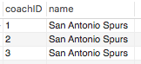

**SELECT owner.ownerID, coach.name FROM owner, coach WHERE owner.ownerID = 3 AND coach.name = 'Gregg Popovich';**



**#All players on San Antonio Spurs who have ever gotten more than 5 assists**

**SELECT player_game_stats.playerID FROM player_game_stats WHERE player_game_stats.assists > 5 AND player_game_stats.`team name`= 'San Antonio Spurs';**

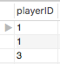

**#Every member of Miami Heat's teams' stats from both games**

**select * from player_game_stats where player_game_stats.`team name` = 'Miami Heat';**

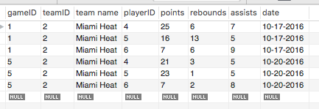

**#Coach info -> Owner info -> Team info**

**SELECT * FROM coach LEFT JOIN owner ON coach.coachID = owner.ownerID**

**LEFT JOIN team ON owner.ownerID = team.teamID;**

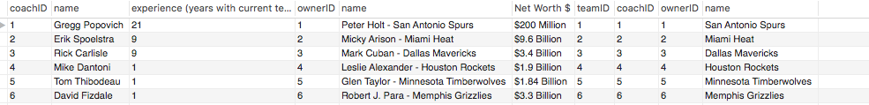

**#Team info -> Every player info -> Coach info**

**SELECT * FROM team LEFT JOIN player ON team.teamID = player.teamID**

**LEFT JOIN coach ON player.teamID = coach.coachID;**

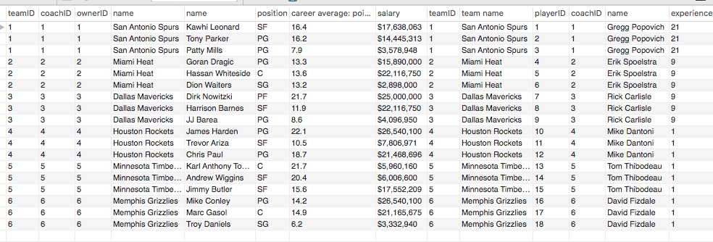

**#List of all players on Mavericks and Rockets**

**(SELECT name FROM player WHERE player.teamID = 3) UNION (SELECT name FROM player WHERE player.teamID = 4);**

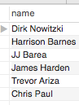

**#Gets one player from each team except for team with teamID = 6 (Memphis Grizzlies)**

**select name as 'Player Name' FROM player WHERE teamID < 6 GROUP BY teamID;**

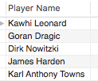

**#Reverse alphabetical list of team names**

**select name as 'Team Name' from team order by name DESC;**

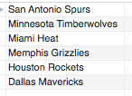

**#List of all positions played by all players except those on Timberwolves, Grizzlies, and Rockets (playerID < 10 gets rid of rockets)**

**SELECT DISTINCT position from player where teamID < 5 AND playerID < 10;**



**#All games played on October 17th**

**Select * from game where date like '10-17_____';**

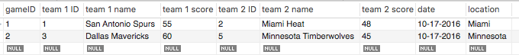

**#Average number of points scored by one player on each team**

**select teamid, avg(points) from player_game_stats group by teamid;**

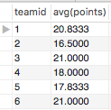

**#Average number of points scored by whole team per game**

**select `team name`, sum(points)/2 from player_game_stats group by teamid DESC;**

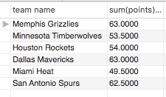

**#List of all players who are team with teamID = 3 (Dallas Mavericks)**

**select name from player where `team name` = (select name from team where teamID = 3);**

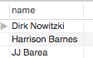

**select points as 'Kawhi Leonard Points in Game 1 and Game 2' from player_game_stats where playerID in (select playerID from player where name = 'Kawhi Leonard');**

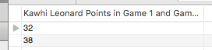

**#Find person who has scored the most points in a single game**

**select name from player where playerID = (select playerID from player_game_stats where points >= ALL(select points from player_game_stats));**



**##Simulates intersect b/c intersect does not work in mysql**

**select * from player where playerID in (select playerID from player_game_stats where points > 25);**

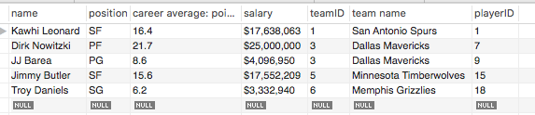

**#Points and Assists for every player**

**select name as Player, points as Points, assists as Assists from player,player_game_stats where player.playerID = player_game_stats.playerID;**

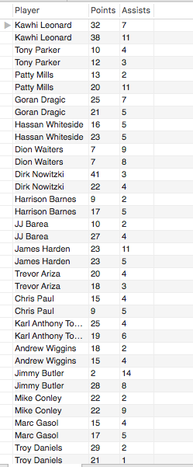

**#Points and Assists for every player who has gotten, at least once, more than 20 points and less than 8 assists in a game**

**select name as Player, points as Points, assists as Assists from player,player_game_stats where player.playerID = player_game_stats.playerID AND player_game_stats.points > 20 AND player_game_stats.assists < 8;**

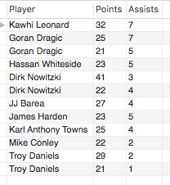

**#Most Points scored by a player from the Memphis Grizzlies (teamID = 6)**

**select name as Player from player where playerID = (select playerID from player_game_stats where teamID = 6 AND points = (select max(points) from player_game_stats where teamID = 6));**



**#Every players stats for each game along with their salary, name, career average: points, and postion**

**select name, position,playerID, salary, `team name`, `career average: points`, gameID, points, rebounds, assists from player NATURAL JOIN player_game_stats;**

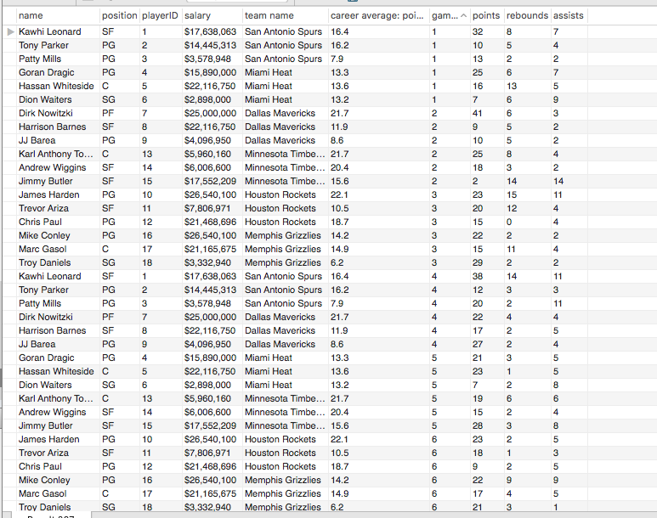

**#Same as above except just player whose position is SF and play for the Timberwolves or Spurs**

**select name, position,playerID, salary, `team name`, `career average: points`, gameID, points, rebounds, assists from player NATURAL JOIN player_game_stats where position = 'SF' AND (teamID = 1 OR teamID = 5);**

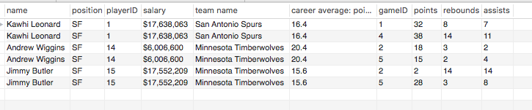

**#How many players got over 25 points in a game and were on the Grizzlies or Rockets**

**select count(points) from player_game_stats where points > 25 AND (teamID = 4 OR teamID = 6);**



**#Teams with players who had less than 25 points, more than 4 assists and more than 5 rebounds in at least one game. Format: Team name followed by stats of individual person**

**select `team name`, playerID, points, assists, rebounds from player_game_stats where assists > 4 group by playerID having points < 25 AND rebounds > 5;**

